An Insight to Human Memory

Majority of people believe that their memory weakens as they grow in their age. This is only applicable for people who don’t use their memory in a proper manner. Memory is similar to a muscle, the more it used, the better it is. The more it is left alone, the weaker it gets.

Memory functions by creating links among information, fitting the details into psychological frameworks. The more you are heartily memorizing, the more facts you can store in your memory, and the more stronger will be the memory.

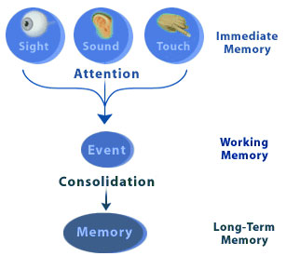

During the learning, majority of the people have to use their memories in a very intense manner. This is done just to keep in mind details and pass exams. Once the learning/studying period finishes, people tend to use their memory in a lazy manner so it gets flabby with time.

In today’s computers, memory is programmed as a huge range of self-governing, digital bits of information that are "randomly reachable."

This means that computers can carry information about your best friend without making any associations. Storage of memory in a human mind is totally different as compared to the computers; it works like recalling your best friend's phone number may very well bring to mind your friend's face, a pleasant conversation that you had, and the title of the movie that the two of you are going to see. While computer memories are discrete and informationally simple, human memories are tangled together and informationally complex.

Human memory is very complicated and rich, since it works among associations. When an event is occurred, our brains store the sights, smells, sounds, and our own impressions together into a relationship. That relationship itself is the memory of the event. Unlike computer memories, a human memory is not a discrete thing that exists at a particular location; instead, it is an abstract relationship amongst thoughts that arises out of neural activity spread over the whole brain.



But how is the memory relationship actually made? The process from both a biological and a behavioral perspective is critically dependent on reinforcement. Reinforcement can come in the form of repetition or practice; we remember that two plus two equals four because we've heard it so many times. Reinforcement can also occur through emotional arousal; most people remember where they were when they heard that John F. Kennedy was shot because of the highly emotional content of that event. Arousal is also a product of attention, so memories can be reinforced independent of context by paying careful attention and consciously attempting to remember.

